

FACULTY OF ENGINEERING AND THE BUILT ENVIRONMENT

DEPARTMENT OF ELECTRICAL ENGINEERING TECHNOLOGY

Ramolatela Lebaea

221064591

NETWORKS 2B

Huawei VRP and Configuration Basics

11 September 2023

Dr. A. Alonge

Table of Contents

1. INTRODUCTION 2
   1. Objectives 2
2. APPARATUS 2
3. OUTPUT RESULTS 4
4. QUIZ 8
5. CONCLUSION 9

Figure 1: Network Diagram 2

Figure 2: PC1 Details 3

Figure 3: Router Command Prompt 4

Figure 4: Router Command Prompt 5

Figure 5: Router Command Prompt 6

Figure 6: Router Command Prompt 7

Figure 7: Router Command Prompt 8

# INTRODUCTION

## Objectives

The main aims of this lab are to understand how to navigate command line views, become familiar with common networking commands, and learn how to utilize command line help and shortcuts effectively

# APPARATUS

* 1× Desktop computer
* 1× Router
* CTL connecting wires

1. NETWORK DIAGRAM

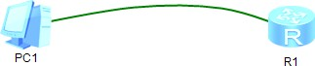

*Figure 1: Network Diagram*

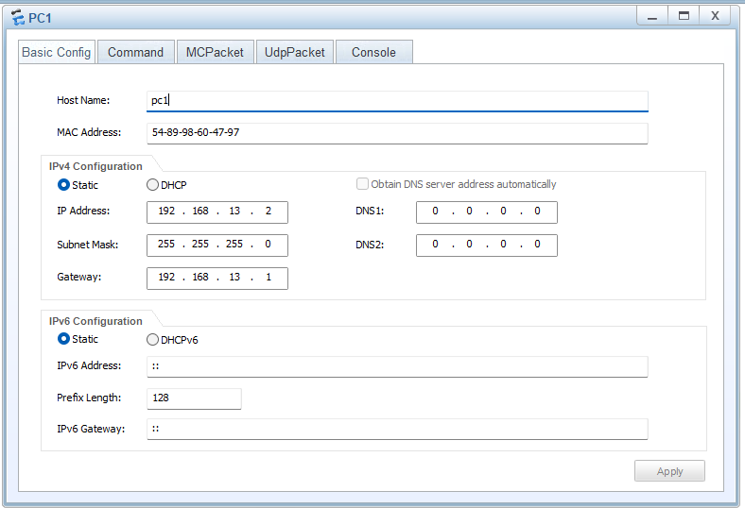

*Figure 2: PC1 Details*

# OUTPUT RESULTS

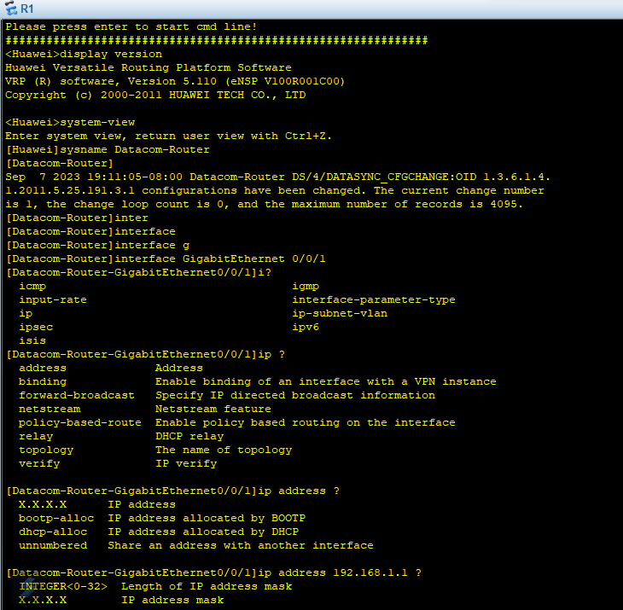

*Figure 3: Router Command Prompt*

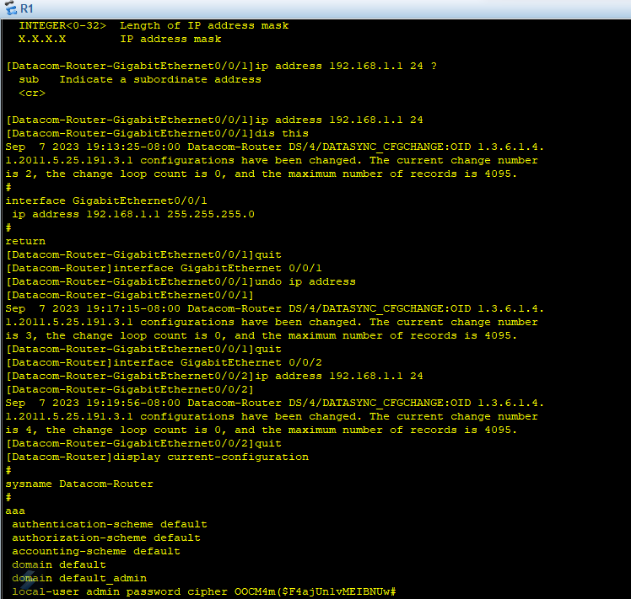

*Figure 4: Router Command Prompt*

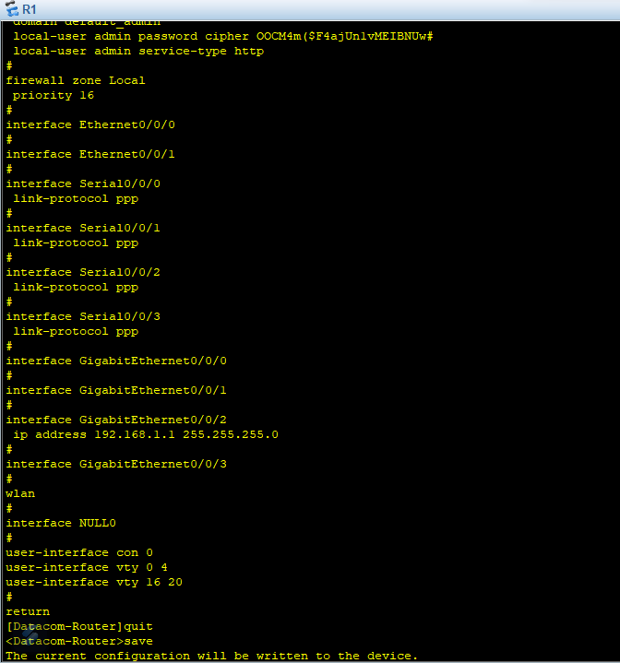

*Figure 5: Router Command Prompt*

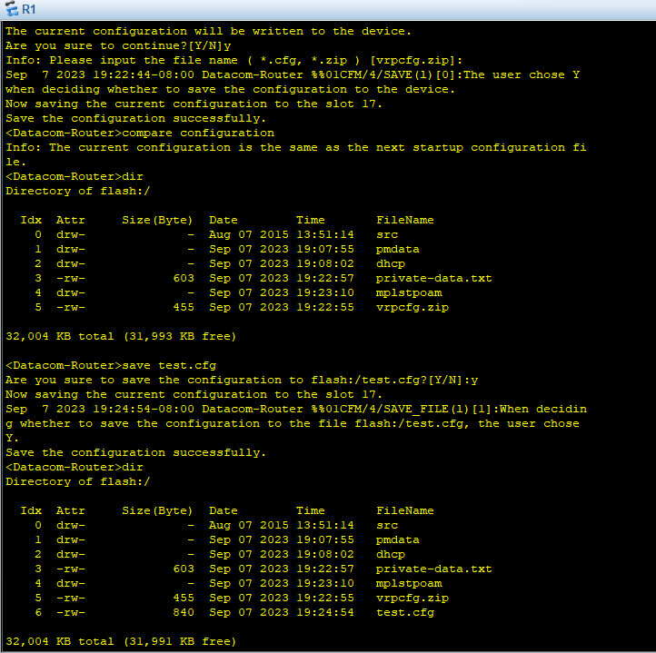

*Figure 6: Router Command Prompt*

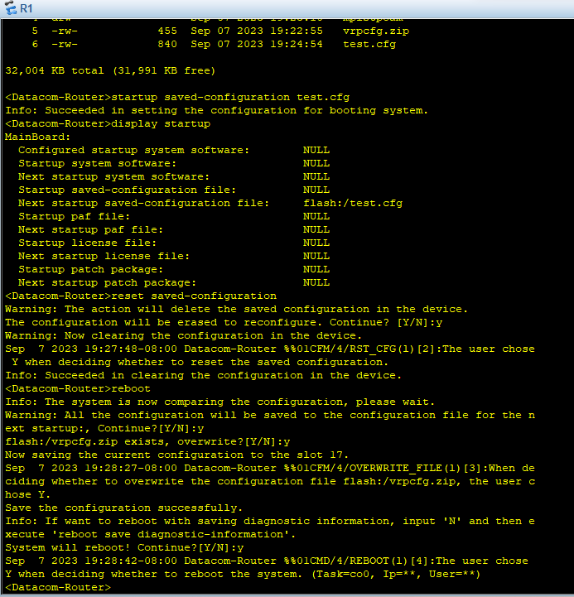

*Figure 7: Router Command Prompt*

# QUIZ

The reason why the configuration stays even after restarting the device is that when you use the "reset saved-configuration" command, it deletes the saved configuration file but does not erase the configuration that is currently in use. To completely get rid of the configuration, you have two options: either use the "reset saved-configuration" command and then reboot the device, or go through the configuration and manually remove each part using the "undo" command. In this lab, they chose to reboot the device after using the "reset saved-configuration" command, which wiped out the configuration during the restart.

# CONCLUSION

In conclusion, all the required results were met. I learned how to set up basic device settings, save them, and restart the device to check the changes. It was a good experience, and I feel more skilled at configuring and managing network devices now.